iMovie Instructions
- Tap the iMovie icon
- Tap on the plus sign at the bottom and choose “New Trailer”.
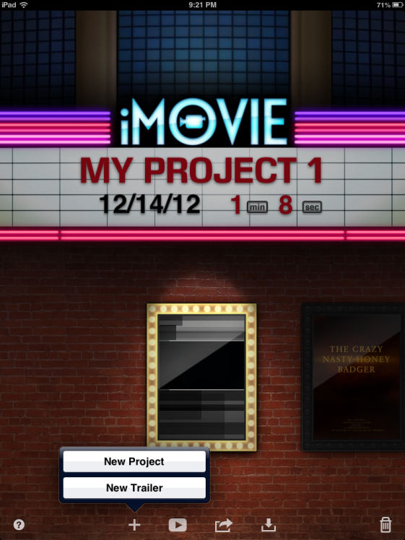
- The trailer options will pop up. Choose “Teen” and tap “create”.
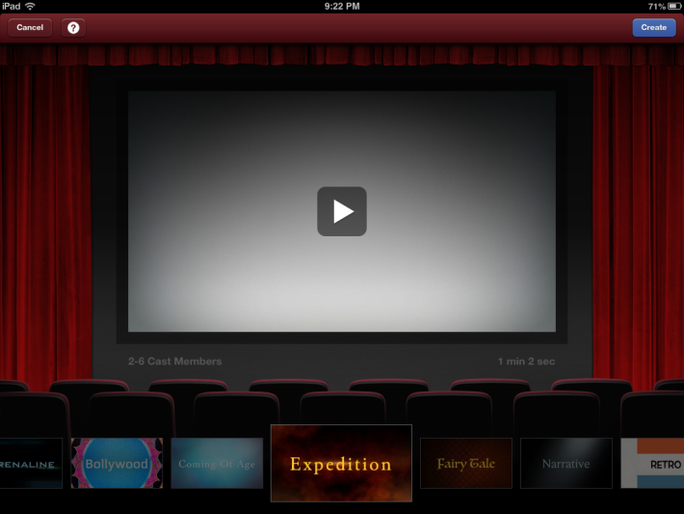

- Follow the directions on your storyboard to fill in the outline on this tab.
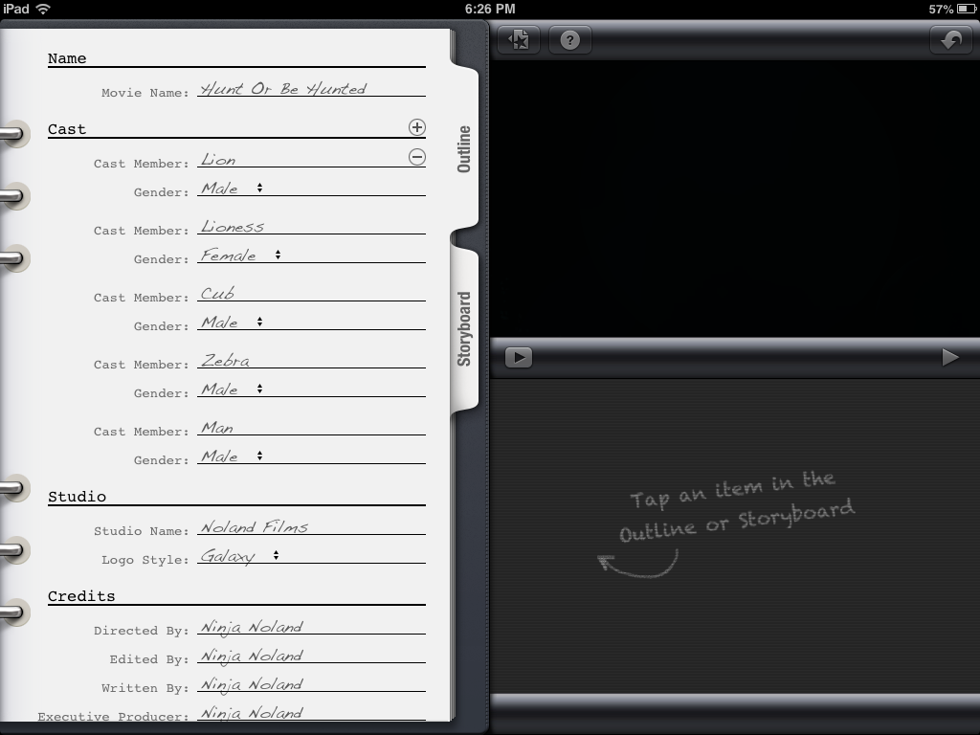

- Tap the “Storyboard” tab. Follow the directions on your Storyboard to change the information on the blue boxes.
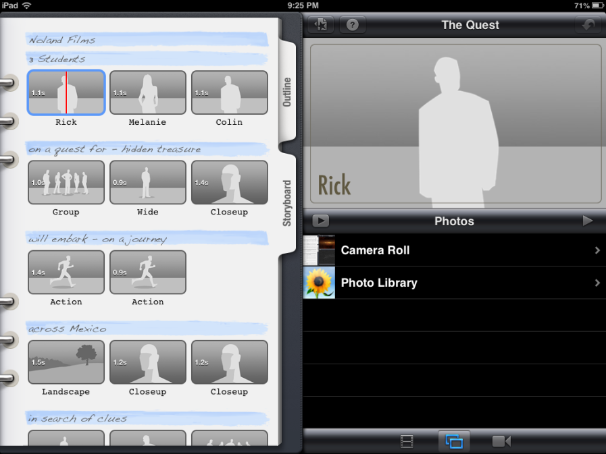
- To save pictures to the iPad, follow the directions at the bottom of this page. You can also choose to take pictures of yourselves acting out each scene by clicking the video camera icon at the bottom. Once you have added pictures, you can select your photo from the gallery and repeat for each image. You can pick whatever photos you would like, but make sure they make sense with what you wrote in the blue boxes.
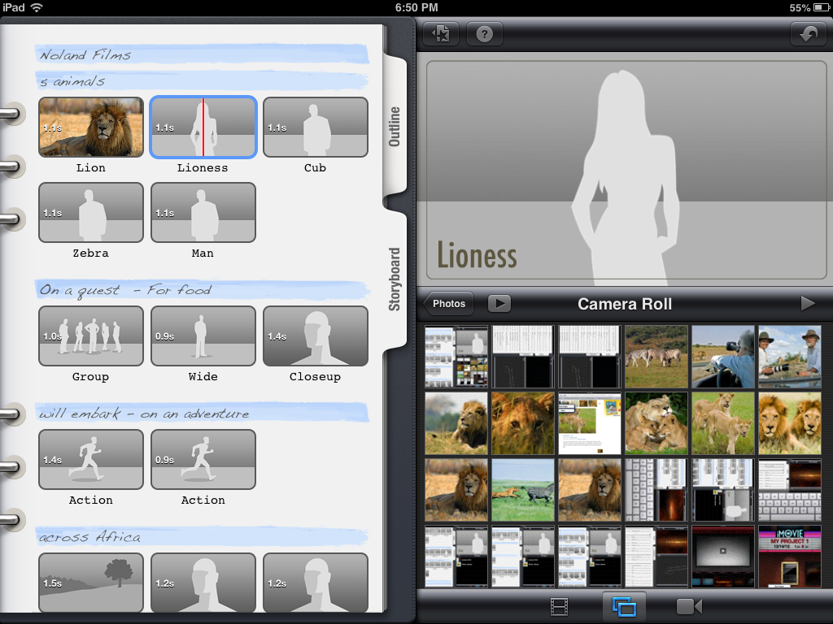
- When done hit the play button to view your film. Once done press the star at the top middle to save your movie to the iMovie library.
Save
Play

How To Save Photos On iPad
- Tap on Safari on the iPad.
- Type either Pixabay.com or Morguefiles.com to find images and press search.
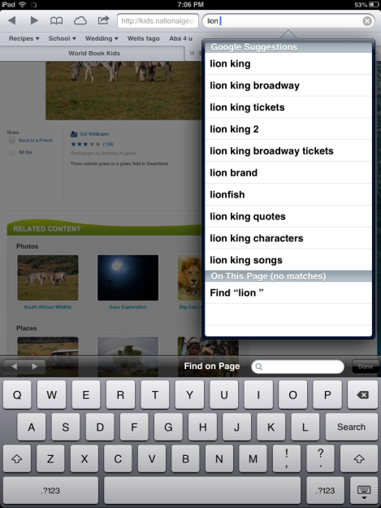

- Tap the link to these websites and type what you are looking for at the top.

- Look through the photos and tap on the photo you would like. Press and hold lightly and tap “Save Image”. Your photos will be saved in your “Photos”.
